Manual GUI Tests Plan

# Test 1: Laying out the Board and the Chess-Boxes

**What you should observe:**

* Alternating white and black Chess Boxes
* Total number of Files = 8
* Total number of Ranks = 8

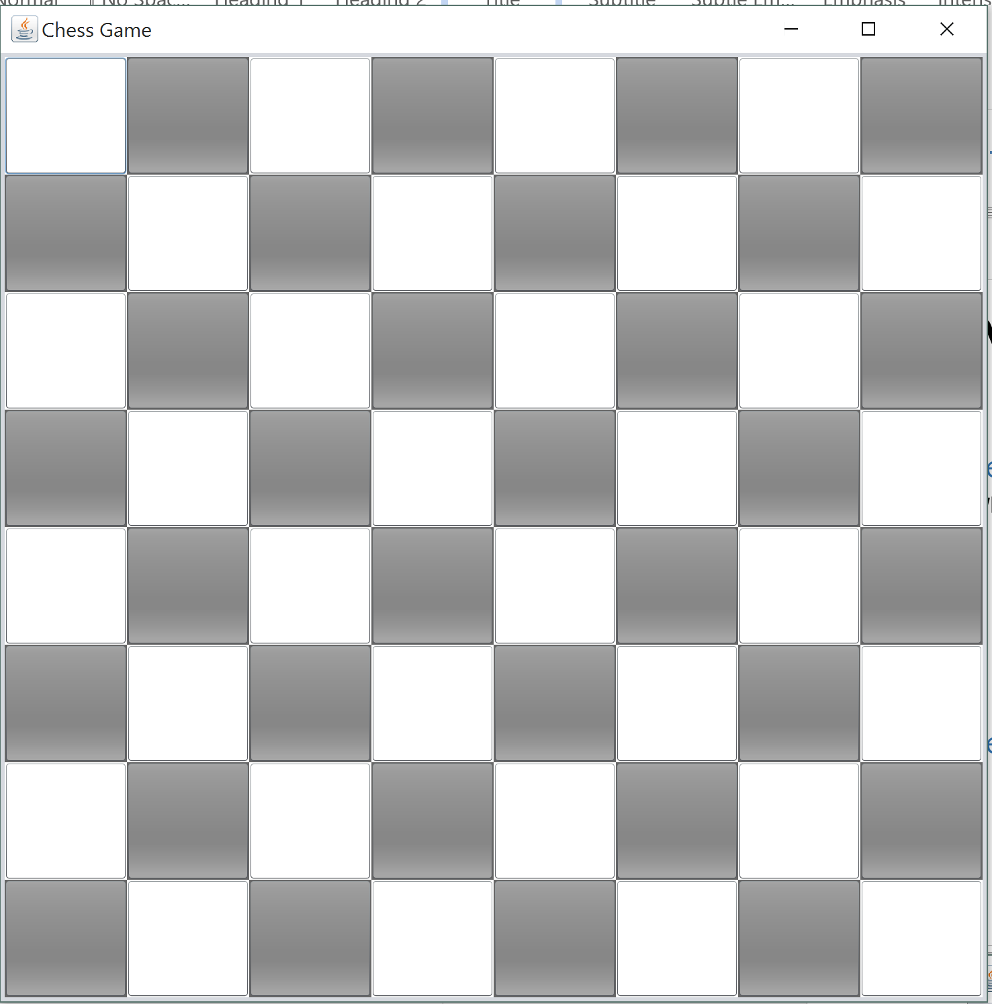

# Test 2 : Setting Game Pieces

**What you should observe:**

* Pieces are in their respective positions
* White King in White box
* Black King in Black box
* Images load appropriately

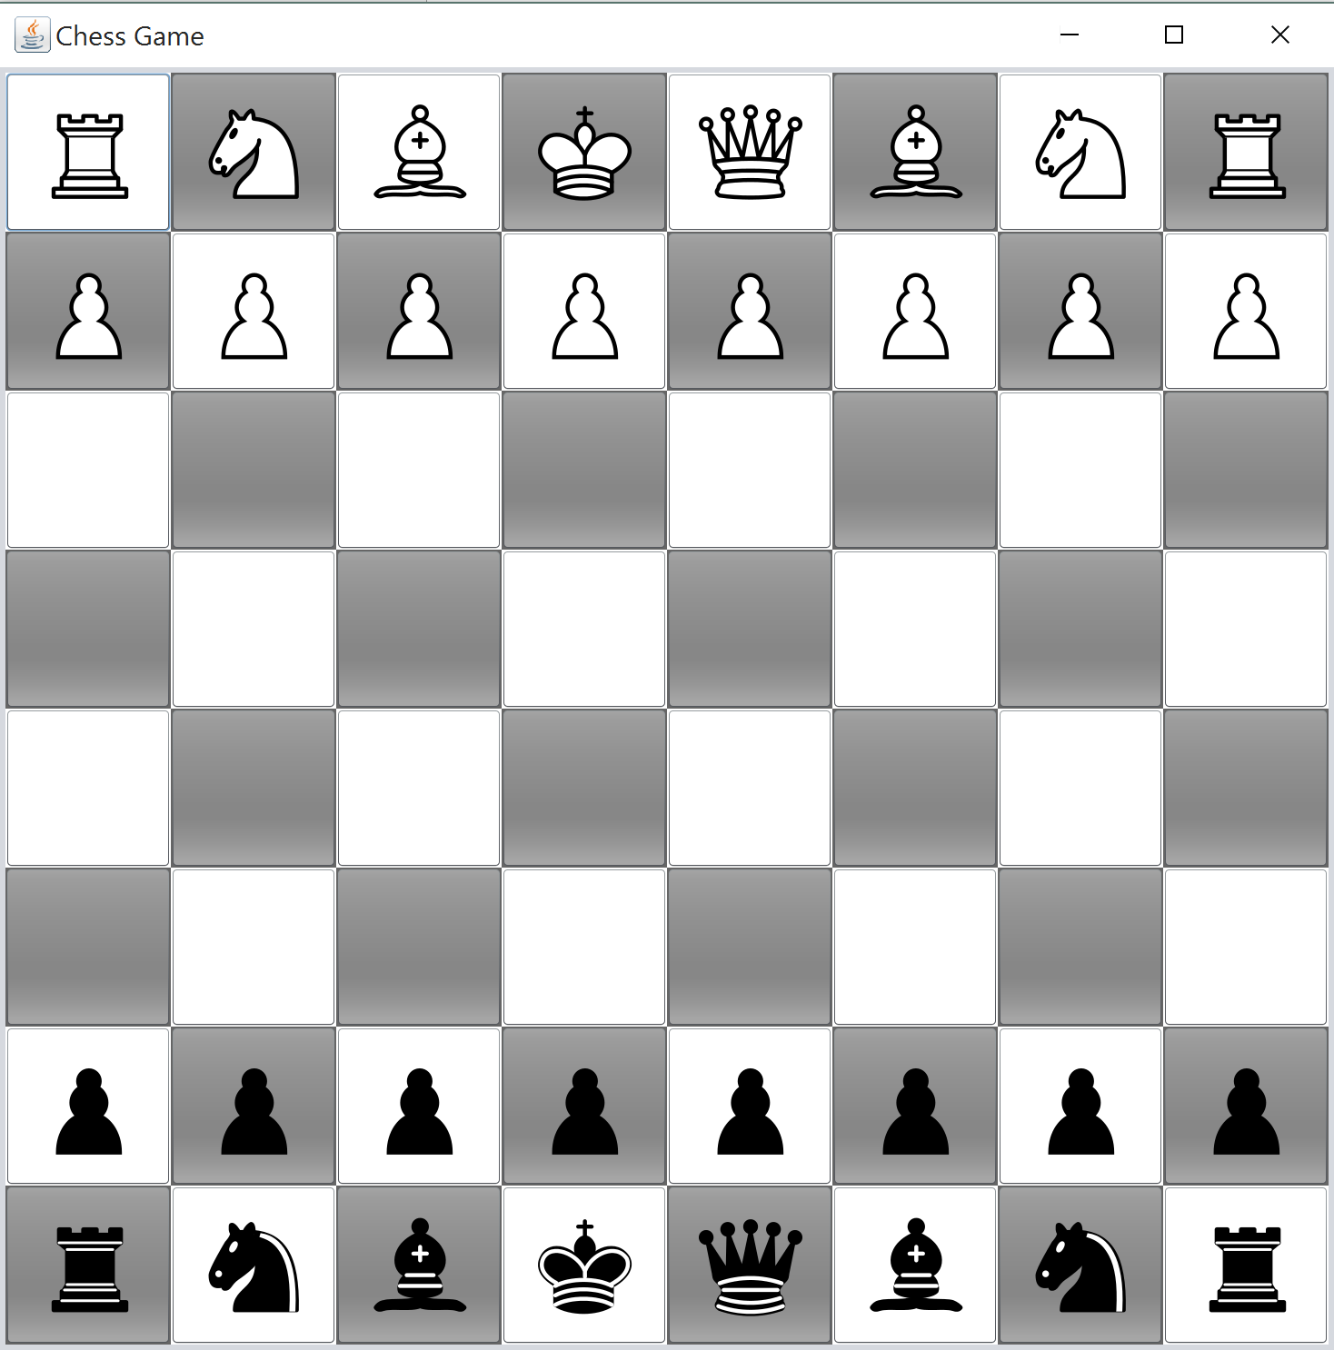

# Test 3: Custom Pieces Special Board Set-up

**What you should observe:**

* Custom pieces are in their respective positions
* Images load as desired

# Test 4: Game Status: Turn

**What you should observe:**

* Appropriate Player’s Turn is shown

# Test 5: Game Status: Check

**What you should observe:**

* Appropriate status should be displayed
* Pieces should only be able to move if they can **avoid** the Check

# Test 6: Game Status: Check-mate

**What you should observe:**

* No pieces should be pick-able
* Game Stops and appropriate status is shown

# Test 4: Piece Move

**What you should observe:**

* Piece moves to desired box
* It is removed from source box